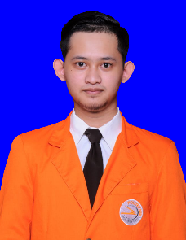info.pnginfo.pnginfo.png

**Staff Honorer Bidang Kemahasiswaan, Alumni dan Kerjasama**

**Teknisi Jaringan Polban Gd.Direktorat**

My experience during an internship at POLBAN (POLYTECHNIC BANDUNG) is to monitor the server and then do maintenance, replace the problematic cables and operate Linux accompanied by a work report that will later be given to the supervisor and a lot of new knowledge that I got during the initial stage of the internship in the vocational high school program.

POLTEKPOS, Bdg  
December 2018 - October 2019

instagram.com/bukandikidilan

twitter.com/DikiWahyuN

Email dikiwahyunugraha619gmail.com

**PERSONAL DETAILS**

**Interests**Music  
Travelling  
Sports  
Photography

**Computer**UI/UX  
Programmer  
Latex&MandeleY  
Ms.Office

**Knowledge**Responsive design  
Art design  
Analysis System  
Grids and layout

**Specialities**Graphic design  
Logo design  
Responsive web design

Hello! I am Diki, a 23 year old web designer based in Bandung, Indonesia.

And i like a new challenge and searching for new knowledge because i want to deepen the programming , system analys, UI/UX and then database.

facebook.com/diki.nugrahaii

**SKILLS**

**PROFILE**

POLBAN,Bdg  
March 2014 – July 2014

**EXPERIENCE**

**EDUCATION**

High School Stevenson High School, INA

University POLITEKNIK POS INDONESIA

Contact +62 877 1923 3240

Web www.dikiwahyunugraha.edu

D.O.B 02 Oktober 1997

Name Diki Wahyu Nugraha